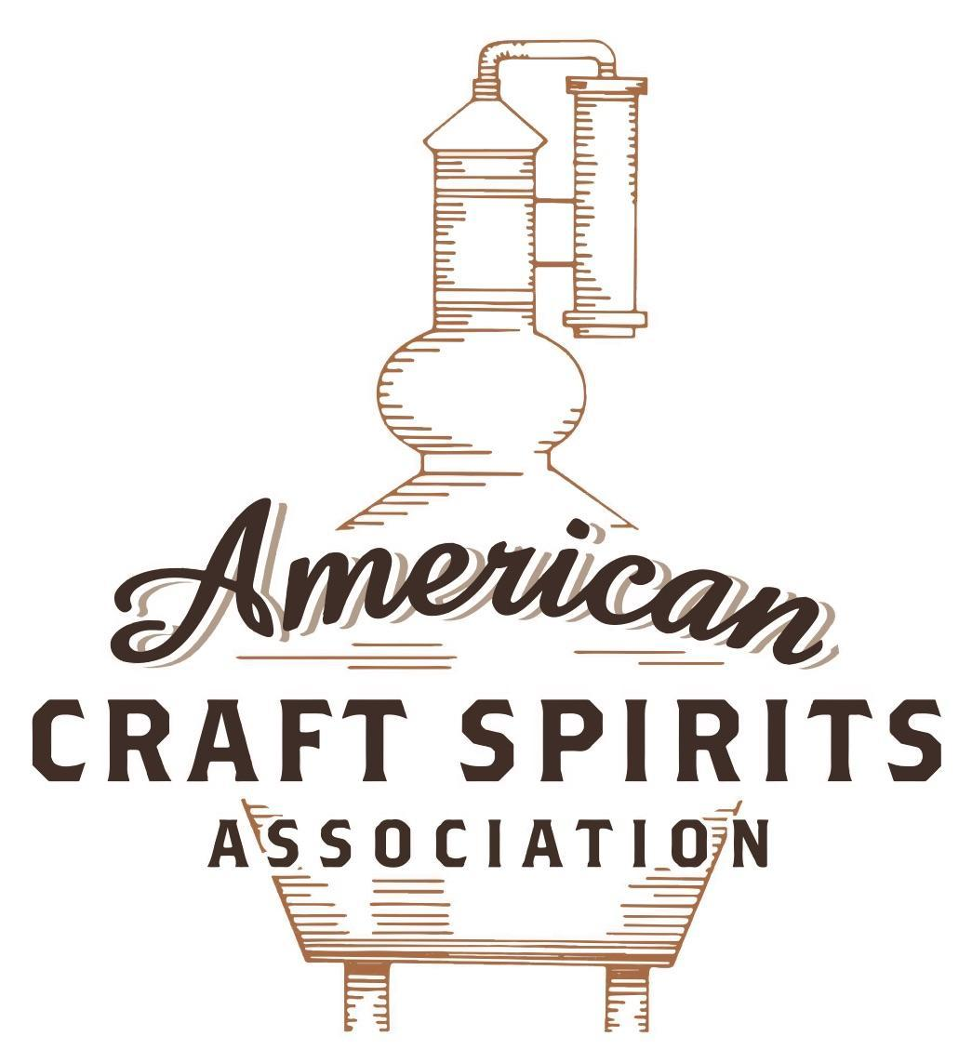
Spirits DtC Shipping Guide

This guide summarizes the direct-to-consumer shipping rules for distilleries in all 50 states and D.C. and also addresses the measures state governments have taken to ease delivery and shipping restrictions during the COVID-19 pandemic.

DtC Quick Guide Comparison

Out-of-State Distilleries  Can Ship Into State? |  |  |  | In-State Distilleries  Can Ship Within State?
State | Yes | No |  | State | Yes | No
AL |  | X |  | AL |  | X
AK | X |  |  | AK | X
AZ | X |  |  | AZ | X
AR |  | X |  | AR |  | X
CA |  | X* |  | CA |  | X*
CO |  | X |  | CO |  | X
CT |  | X* |  | CT |  | X
DE |  | X |  | DE |  | X
DC | X |  |  | DC | X
FL |  | X |  | FL |  | X
GA |  | X |  | GA |  | X
HI |  | X* |  | HI |  | ?*
ID |  | X |  | ID |  | X
IL |  | X* |  | IL |  | X*
IN |  | X |  | IN |  | X
IA |  | X* |  | IA |  | X*
KS |  | X |  | KS |  | X
KY | X |  |  | KY | X
LA |  | X |  | LA |  | X
ME |  | X* |  | ME |  | X*
MD |  | X |  | MD |  | X
MA |  | X |  | MA |  | X
MI |  | X |  | MI |  | X
MN |  | X |  | MN |  | X
MS |  | X |  | MS |  | X
MO |  | X |  | MO |  | X
MT |  | X |  | MT |  | X
NE | X |  |  | NE | X
NV |  | X* |  | NV |  | X
NH | X |  |  | NH |  | X*
NJ |  | X* |  | NJ |  | X*
NM |  | X |  | NM |  | X
NY |  | X* |  | NY |  | X*
NC |  | X |  | NC |  | X
ND | X |  |  | ND | X
OH |  | X |  | OH |  | X
OK |  | X |  | OK |  | X
OR |  | X |  | OR | X
PA |  | X* |  | PA |  | X
RI |  | X* |  | RI |  | X
SC |  | X |  | SC |  | X
SD |  | X |  | SD |  | X
TN |  | X |  | TN |  | X
TX |  | X |  | TX |  | X
UT |  | X |  | UT |  | X
VT |  | X |  | VT |  | X
VA |  | X |  | VA |  | X
WA |  | X* |  | WA | X
WV |  | X* |  | WV |  | X*

WI |  | X |  | WI |  | X
WY |  | X |  | WY |  | X

Notes:
*CA: If passed and signed into law, Senate Bill 620 would allow licensed distilled spirits producers in states other than California and licensed distilled spirits manufacturers or craft distillers in California who obtain distilled spirits direct shipper permits to ship directly to consumers in California
*CT: Consumers with appropriate permit may receive alcohol shipments
*HI: Consumers with appropriate permit may receive alcohol shipments; If passed and signed into law, Senate Bill 65 would allow licensed distilled spirits manufacturers in Hawaii and in states other than Hawaii who obtain direct shipper permits to ship directly to consumers in Hawaii
*IL: If passed and signed into law, Senate Bill 0532 would allow licensed distilled spirits producers in Illinois and in states other than Illinois who obtain distillery shippers’ licenses to ship directly to consumers in Illinois
*IA: If passed and signed into law, House File 639 would allow native distilled spirits manufacturers in Iowa and in states other than Iowa who obtain direct shipper permits to ship directly to consumers in Iowa and to consumers in states other than Iowa
*ME: If passed and signed into law, Legislative Document 1358 would allow distilleries outside of Maine with current manufacturer licenses and distilleries licensed in Maine who obtain spirits direct shipper licenses to ship directly to consumers in Maine
*NJ: (1) If passed and signed into law, Assembly Bill 3167 would allow a craft distillery licensees to ship no more than 9 liters of distilled spirits to a consumer in New Jersey; (2) If passed and signed into law, Senate Bill 3020 would allow craft distillery licensees in New Jersey or in states other than New Jersey to ship no more than 20 liters of distilled spirits to a consumer in New Jersey via common carrier
*NV: Licensed individuals can import one gallon per month of spirits for personal use and the out-of-state supplier must pay excise tax
*NH: If passed and signed into law, Senate Bill 125 would allow licensed liquor manufacturers who obtain direct to consumer shipping permits from the commission to ship directly to consumers in New Hampshire
*NY: Consumer may import up to 90L of liquor per year for personal use without a license; If passed and signed into law, Assembly Bill 3275 would allow licensed liquor manufacturers in states other than New York and licensed distillers and farm distillers in New York to ship no more than thirty-six cases (no more than nine liters per case) of liquor to consumers in New York
*PA: Consumer may place a special liquor order and distiller must ship to a PLCB-operated store
*RI: Distiller can only ship to customer if order was personally placed by customer at distiller's premises
*WA: If passed and signed into law, House Bill 1432 would allow licensed spirits manufacturers in states other than Washington to ship spirits to consumers in Washington
*WV: Distilleries, mini-distilleries, or micro-distilleries licensed in West Virginia or a state other than West Virginia who obtain private direct shipper licenses to ship to a consumer in West Virginia, however the shipments must be made to a retail liquor outlet

LOUISIANA
Shipment Outbound – LA’s ATC Commissioner may regulate export laws regarding alcohol, but no specifics other than reporting and tax requirements exist (R.S. 26:141).
Shipment Inbound – No, alcoholic beverages must be sold to the holder of a wholesaler’s permit and delivered to the wholesaler’s place of business as shown in the permit (R.S. 26:142).
Shipment Intra-state – No. Microdistilleries with Retailer Class A permits may sell their product at retail for consumption on or off the licensed premises but have no privileges to deliver (R.S. 26:71.3(A); 26:153(A)).
COVID-19 Measures – COVID measures in LA have allowed establishments to serve wine, beer, and frozen specialty drinks in sealed containers to their customers in their cars. No delivery or shipping has been allowed.
Link: https://atc.louisiana.gov/docs/Updated%20Phase%203%20Guidance.pdf
Citation (shipment)
Louisiana Revised Statutes
§ 71.3. Microdistillery; retail sales for consumption on or off premises.
A. Any person who has properly obtained a microdistiller’s permit as provided for in R.S. 26:71, shall be authorized to engage in the distilling, making, blending, rectifying, or processing of any alcoholic beverage in Louisiana in a quantity not to exceed twelve thousand gallons during the licensed year. The holder of such permit shall also be authorized to sell the manufactured beverages at retail for consumption on or off the licensed premises, if the holder also has been issued a Retailer Class A permit.
§ 141. Export of beverages controlled by commissioner.
The commissioner may promulgate rules regulating the sale, handling, distribution, storage, and transportation of alcoholic beverages for delivery beyond the borders of the state. The failure to comply with any such rule shall, in addition to any other penalties imposed by this Chapter, be cause for the suspension or revocation of the dealer's permit.
§ 142. Distribution through wholesalers only.
Except as provided for in R.S. 26:71.3, 85, 271.1, and 359, no alcoholic beverage produced or manufactured inside or outside of this state shall be sold or offered for sale in Louisiana or shipped or transported into or within the state except to the holder of a wholesaler’s permit and for delivery at the place of business of the wholesaler as shown in his permit.
§ 153. Delivery of alcoholic beverages; certain retailers; third parties; requirements; limitations.
A. Notwithstanding any law to the contrary, any liquor retailer permitted pursuant to R.S. 26:71(A)(3)(b) or any retailer permitted to sell alcoholic beverages for off-premise consumption may deliver, either on the licensed premises itself or at a residential or commercial address designated by the consumer, products lawfully sold to and purchased by such consumer, provided that:
(4) Deliveries to consumers are made only by the Class B liquor retailer or a retailer permitted to sell alcoholic beverages for off-premise consumption, or an employee of such retailer, and only to consumers at a residential or commercial address in this state.
B. Notwithstanding any law, rule, or regulation to the contrary, any liquor retailer permitted pursuant to R.S. 26:71(A)(3)(b) or a retailer permitted to sell alcoholic beverages for off-premise consumption, may use electronic means to do the following:
(1) Market the alcohol products it is licensed to sell.
(2) Receive and process purchase orders placed by a consumer of legal drinking age, which orders may then be delivered to such consumer on the licensed premises itself or at a residential or commercial address in this state designated by the consumer in accordance with Paragraph (A)(4) of this Section.
C. A Class B liquor retailer permitted pursuant to R.S. 26:71(A)(3)(b) or a retailer permitted to sell alcoholic beverages for off-premise consumption may market, receive, and process orders for alcohol products under this Section using electronic means owned, operated, and maintained by a third party…
LA Law Book: https://atc.louisiana.gov/docs/law%20book.pdf

The American Craft Spirits Association (ACSA) is working diligently to give our members and industry partners relevant, current updates on statutes and regulations impacting production, sale and distribution of spirits. With the declaration of the novel coronavirus (COVID-19) in early 2020, many states have issued temporary policy changes or longer-term modernization of alcohol beverage laws. State statutes, regulations created by the state alcohol regulatory authority, as well as any other relevant guidance provided by such authorities (such as advisories, opinions, bulletins, etc.) were reviewed in creation of this document. No city or county ordinances were reviewed. Distillers should be aware that even in states where direct shipping is permissible, always remember to avoid shipping to dry counties. Please consult with your state guild or alcohol beverage authority for the most up-to-date information. This content is intended for educational and informational purposes only. ACSA's pro bono law firm of Malkin Law P.A. provided the core content found in this comprehensive overview of the spirits distribution after COVID-19. It was completed in August 2021 and will be updated regularly. If you have updates you would like to provide, please send to legislation@americancraftspirits.org or directly to the law firm at: ryan@malkin.law / malkin.law. Thank you.

